PRE-INSTALLATION CHECKS

Before proceeding to install the P11D software, please ensure that you have the following:

Hardware requirements

The P11D software requires the following:

- Pentium based PC.
- Microsoft Windows 98/2000/ME/XP or NT version 4 or later.
- 64 Megabytes of memory (minimum, 128 Megabytes recommended).
- 50 Megabytes of free disk space for the basic system, plus enough to store any client files that may be created.
- A laser printer with 16 Megabytes of memory

The following points should be also considered:

- Do you have sufficient rights to install the software? You require Read, Write, Create, Erase and Modify rights to the directory where you wish to install the software.
- Do you have ‘Administrator’ rights on the computer? This is required for the first running of the newly installed software. After it has been run once by an Administrator it can be run under a user login.

System requirements:

- Microsoft Internet Explorer version 4.01 SP2 (or higher) is required, and version 5.x is recommended. This can be downloaded from www.microsoft.com.
- Under Windows 98, the year 2000 critical updates must also be installed. These can be found at:
http://www.microsoft.com/windows98/downloads/contents/WURecommended/y2k/Default.asp
and
http://www.microsoft.com/windows98/downloads/contents/WURecommended/y2k2/Default.asp
- Under Windows NT4, SP6 is required, which can be downloaded from www.microsoft.com.

Windows 95 / 98 and NT 3.5 / 4

As mentioned in our March 2003 newsletter, please note that under Microsoft's life cycle policies, Windows 95 and Windows NT 3.5 entered their "End of life" phase from 31 December 2002. This means that a number of the components, which the P11D system depends on, will not be tested by Microsoft on Windows 95 or Windows NT 3.5 after this date. As a consequence of this we might be unable to resolve some operational issues experienced by users running Windows 95 or Windows NT 3.5. Windows 98 and Windows NT 4 will enter their "Non-supported" phase on 30 June 2003 and their "End of life" from 30 June 2004. If you are currently running P11D on these operating systems we recommend that you consider an upgrade before the appropriate date. Further details are available at: http://www.microsoft.com/windows/lifecycle/desktop/consumer/default.mspx.

INSTALLATION INSTRUCTIONS

The P11D software is installed locally (onto the hard drive of your PC). The P11D InstallShield Wizard will guide you through the entire process of installing the software.

Please note that the P11D installation always installs and registers components to the local machine’s system directory. The user performing the installation must have sufficient privileges to allow this (as mentioned in the Pre-Installation Checks section).

Close all programs before attempting to install the P11D software. Insert the P11D CD into the CD drive of your machine.

If the InstallShield wizard does not automatically appear after a few seconds, select Start > Run and type in or browse to Setup.exe in the root directory of the CD. P11D will then prepare the InstallShield Wizard that will guide you through the rest of the installation process, as featured below.

First, you will be prompted for the serial number (as the screen below). Please enter the 20-digit code provided on the CD case. The serial number is not case sensitive.

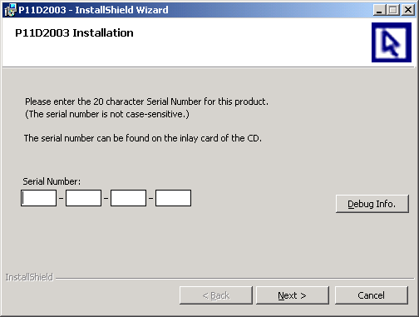

The Debug Info button displays technical information – you do not need to click this button during the installation process, but you may be asked to do so if you need to contact the P11D support team regarding the installation. Click Next to continue with the installation.

Having accepted the serial number, the next screen, as shown below, indicates that you may now install the software. Click Next.

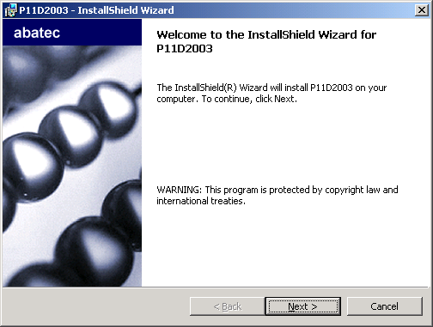

The following screen allows you to choose where on the local drive to install the software. The default location C:\Program Files\Deloitte\P11D2003\ is already displayed. Although we recommend that you install the software to this location, you may change this location by clicking Change and browsing and selecting the required location.

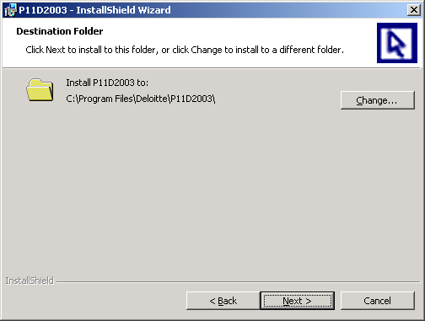

Click Next to choose the working directory.

The next screen, as below, allows you to choose where to open the P11D databases from, i.e. the location of the data. A default location is already displayed.

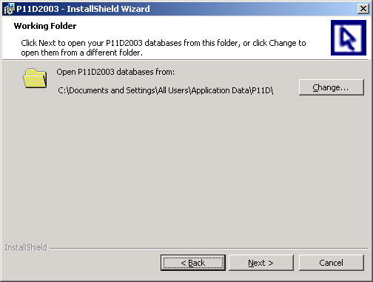

You may change this to a local or network location by clicking Change, which takes you to the screen below. Then, you need to browse and select the required folder. We recommend that you change this to a network location. Click OK to return to the previous screen.

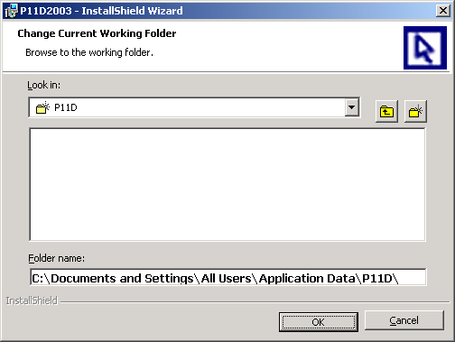

If you have previous installations of the P11D software you will already have a working directory (‘working folder’) containing P11D data files. Please select this directory as your working folder.

Click Next to continue.

A screen notifying you that you are about to install P11D will appear as below. To continue, click Install.

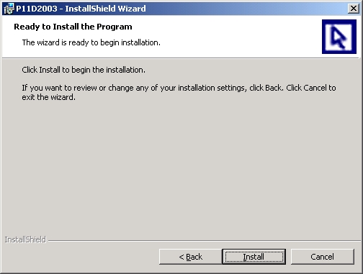

The InstallShield Wizard will then install P11D. This may take several minutes. You may be asked to reboot your PC. When the process is complete, you will see the final screen as below, click Finish to exit the wizard.

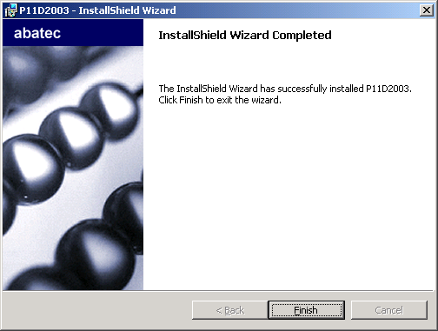

The installation will have created a shortcut to P11D under the Start menu. You will be able to launch P11D by selecting Start > Programs > Deloitte > P11D2003 (or the location that you have changed this to during installation).

CHANGING WORKING DIRECTORY POST INSTALLATION

If you do not set the P11D working directory during installation, you can change it within the application by selecting File > Change Directory.

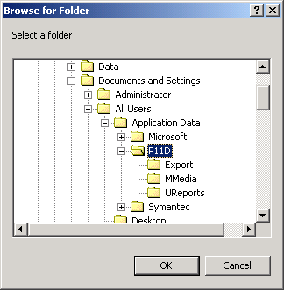

If you wish to redirect the application to a data directory via a UNC path then this needs to be specified in the P11D configuration file (P11D2003.ini), located in the P11D application directory. When the application is closed you will need to update the line “WorkingDirectory=” with your UNC path.

When a working directory is changed post-installation you may see a prompt to create a number of output directories, as below. These are standard sub-directories of the main working directory, which are required by the P11D application, and are used to store customised reports, templates and exports. Ordinarily these sub-directories would have been created by the installation wizard.

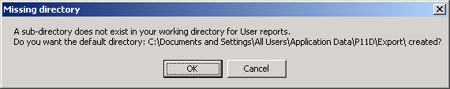

GUIDELINES FOR SYSTEM INTEGRATORS

Installation Image Structure

The P11D2003 installation is a Microsoft Windows Installer (Version 2) installation package, which was authored using InstallShield Developer 7.04. The installation image on the CD consists of the following files:

Filename | Size | Description
AUTORUN.INF | 1 KB | CD AutoRun
SETUP.EXE | 200 KB | Launcher for the Abacus installation
SETUP.INI | 1 KB | InstallShield produced .ini file
0X0409.INI | 5 KB | InstallShield produced .ini file
INSTMSIA.EXE | 2 MB | Installation for Microsoft Windows Installer (Win9X)
INSTMSIW.EXE | 2 MB | Installation for Microsoft Windows Installer (NT4)
ISSCRIPT.MSI | 500 KB | InstallScript Microsoft Windows Installer database
P11D2003.MSI | 25 MB | P11D2003 Microsoft Windows Installer database
DATA1.CAB | 15 MB | Compressed P11D2003 application files
PYEARS\*.* |  | Optional installation images (non-Windows Installer) for prior year versions of P11D.

Installation Properties

During the installation the values of several P11D2003 specific public properties are set via the installation dialog screens. These properties allow access to the software and determine the destinations of the files to be installed. These properties are:

Property | Dialog | Description
INSTALLDIR | [ProgramFilesFolder]  Deloitte\P11D2003 | Destination location for Program files (local only)
WORKINGDIR | [CommonAppDataFolder]  P11D2003 | Destination location for P11D Database(s) and user template files
ISX_SERIALNUM |  | Product Serial Number

These properties can also be set on the command line, for example if the installation is to be launched silently. Note that the Serial Number must be entered without hyphens.

An example command line to install the P11D2003.msi package with a basic user interface would be:

msiexec /i “D:\P11D2003.msi” /qb
INSTALLDIR=” C:\program Files\Deloitte\P11D2003” WORKINGDIR=”I:\tax\P11DData” ISX_SERIALNUM=”ABCDE1234567890FGHIJ”

Repackaging the Installation

If you need to repackage the installation in order to deploy P11D2003 within your organisation, you are free to analyse and extract the information and files from the P11D2003.msi and Data1.cab files.

P11D Installation on terminal services

P11D can be run under Windows terminal services (or Citrix).

On the terminal services machine:

- Log in to the machine using an account with the equivalent of local Administrator rights
- Install the P11D software choosing the local install option.
- Run the P11D software on the machine; check that the install is functioning correctly

Users require read and write access to the application directory so that they can access configuration files, template databases, and error logs. The E-mail functionality within P11D uses a third-party component IDSMail, which requires the licence file to be copied into an individual users profile. This license file xxxxxxxx.ID$ (where xxxxxxxx can be any eight characters) is installed into the administrators profile (e.g. C:\WTSRV\Profiles\administrator\Windows folder). This single licence file can be used for all terminal services users, however it must be copied into their individual "Windows" folder if you wish to use e-mail functionality.

For example, you need to put the licence file in the following folders for users User1 and User2:
C:\WTSRV\Profiles\User1\Windows
C:\WTSRV\Profiles\User2\Windows

From a remote machine:

- Setup a shortcut to the P11D executable file in the remote program directory
- Run the P11D program

Installed System Components

The P11D2003 installation will install / upgrade the following Merge Modules:

MDAC 2.6 SP1 | Microsoft OLE
Jet 4.0 SP3, SP5 | CM Dialog ActiveX Control
DCOM95 | RichText Box
DBList | Microsoft Stock Property Page
Microsoft Common Controls 2 | Visual Basic Virtual Machine
Microsoft Standard Data Formatting Object | MSMask
Microsoft Data Binding Collection Object | Microsoft Component Category Manager
MSFlexGrid | Microsoft ADO Data Control
Microsoft C Runtime Library | TABCTL32 OLE Control
Windows Common Control DLL

The P11D2003 installation will install / upgrade the following COM components:

DISPEX.DLL | Idsmai32.exe
MSSCRIPT.OCX | Idsnotes.dll
MSVCRT50.DLL | Maildi32.exe
SCRRUN.DLL | Mfcans32.dll
TDBG5.OCX | Msvbvm50.dll
TODG6.OCX | Msvcrt20.dll
VB5DDB.DLL | Oc30.dll
VBSCRIPT.DLL | Ole2.dll
Apigid32.dll | Ole2disp.dll
Compobj.dll | Ole2nls.dll
Ctl3d32.dll | Olemsg32.dll
Dssock32.ocx | Storage.dll
Dzip32.dll | Testol32.exe
Dzocx32.ocx | Typelib.dll
Gapi32.dll | Vbamap32.dll

